

**GAME DESIGN DOCUMENT**

**Class name : GAM150S19KR**

**Semester and year : Spring 2019**

Team ***APEX*** Roster

Junseok **Yang** - Producer

Wonju **Cho** - Lead Designer

Jookyung **Lee** - Technical Director

Haewon **Shon** - Test Manager

# **Table of Contents**

**Summary**

-High Concept 2

-Detail of concept 2

-Story 2

-Target platform 2

-Target audience & Expected ESRB rating 3

**Game flow**

**-**Main menu 3

**-**Character choice 3

**-**Game play 4

**-**Game end4

**Game Mechanics**

-Character moving & attack keys 4

-Camera moving & lava effect 5

-Win & lose condition 5

-Hit & knockback 6

**Game Characters** 6

**Game Resources** 7

**Game Environment** 7

**Design**

-Visual Design 8

-Audio Design 8

-Behavior Design 8

-Physics Design 9

-Multiplayer Design 9

**Summary**

**High concept**

“APEX” is a 2D platformer action game to win by reaching the top of the tower or defeating an opponent player by Knocking-Back.

**Detail of concept**

“APEX” is tower-climbing PvP game with knock-back. Players can choose their character and each players will fight against each other to be the winner. The game will end if one of the players die or reach the top of the tower. The victory of each character will be presenting unique ending.

**Story**

In 7405, all APEX team members were doing assignments and accidently picked up a usb "Lee Dong-Sik". They insert the usb to computer and checked what it was, surprisingly it was a magic usb which helps the person to achieve their goal. Therefore, the greed of APEX members was coming into their mind, fairy of usb forces them to compete inside of the computer world and all the members of APEX started to fight each other inside the tower of achieve.

**Target platform**

Target platform of “APEX” is PC. The reason is that one of PC’s input device keyboard is wide enough to handle two local players and is easy to access for players.

**Target audience & Expected ESRB rating**

This game control method is simple so recommended to everyone. There will be a minor violation which is pushing each other without any cruel scenes. Therefore, expected ESRB rating will be **“E” for EVERYONE**.

**Game Flow**

**Main menu**

As the players execute the game, four choices will presented to players. Players must choose one of the options, “START GAME”, “OPTION”, “STORY & CREDIT” and “EXIT GAME”. Choosing STORY & CREDIT will show the name of directors for this game. Choosing “OPTION” will allow players to change the screen size between full-screen or windowed-screen, and control the volume.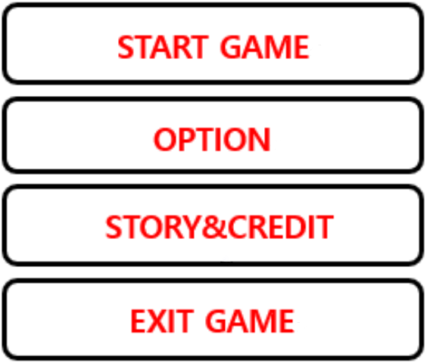

**Character choice**

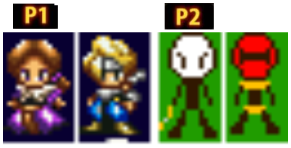

When the players choose the “START GAME” option, it will show players three scenes of game’s story. After that, players can choose their character. Each character has own weapon.

**Gameplay**

When the game starts, players can see the simple tutorial about keys on the background map. Few seconds later from the start, lava will show up to the screen and camera will start to move to upside.

While playing the game, players have to push each other by attacking properly. Also, players can get items that falls from the sky. With items, characters can be faster or slower.

**Game End**

Game will end if one of the players fails from the game or reach the top of the tower. In both cases, special ending scene for winner character will be displayed on the screen, and players will sent back to the main screen.

**Game Mechanics**

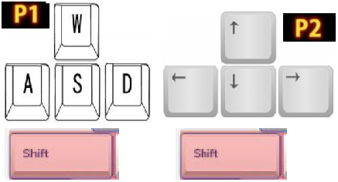

**Character moving & Attack keys**

“APEX” is local-multiplayer game so there will be two players. First player will be controlling the character’s movement with W,A,S,D and attacks with left shift on keyboard just like common FPS game movements. Second player will be controlling the character’s movement with arrow keys and attacks with right shift.

**Camera moving & Lava effect**

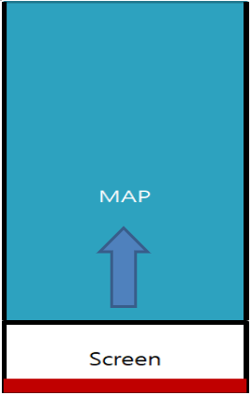

The lava effect will be on the screen, and the y location of camera will move along vertically to the map. This camera movement will force players to climb up.

**Win & Lose condition**

If one of the characters falls into lava or reach the top of the tower, game will end. Everytime game updates, the difference of y position between character and camera will decide fail condition. If it is bigger than the standard, the character will be eliminated and opponent player will win the game. If both characters are alive until reaching top of the tower, the character who touch the ceiling first will win the game.

**Hit & Knockback**

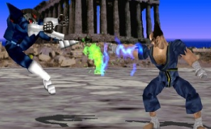

When hit motion occurs, the hitbox of weapon will be checked that is collided to opponent character or not. If the hitbox of weapon is collided with character, knock-back will be generated to opponent character.

The character who got knocked-back will be pushed to backward, and movement will be disabled for specific time.

**Game Characters**

All characters of "APEX" is human and characters in game are from team APEX members. All characters going to climb the tower to achieve their wishes with his or her own weapon that has different attack range and knock-back power.

**Game Resources**

In game, APEX members will be created as characters and they will have their own unique weapon. These weapons are made by pixel picture creating tool. All components will be created by APEX team members. For example, the pictures below will be in-game weapons.



**Game Environment**

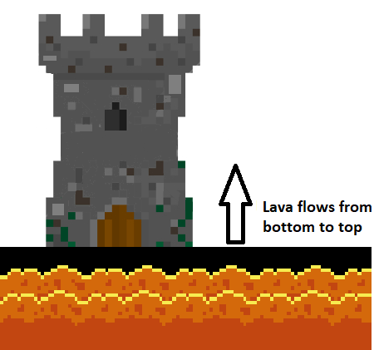

Tower like environment that require players to climb up to the top. This is a virtual place inside of the computer that is generated by fairy of usb.

**Design**

**Visual Design**

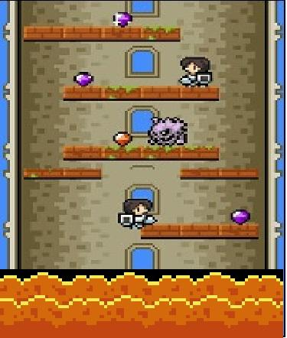

Desired look of the game will be 2D platform game without perspective. The camera movement will be bottom to top that follows the map and also restrict players to move inside of the camera. There will be moving lava with camera movement that forces players to go up to the top

**Audio Design**

Using urgent background music because in “APEX” the lava moves from bottom to top to force the players to go up. Going to use digipen library for the background music. For the sound effects, there will be hit-sound which occurs when players collide each other for preventing boredness.

**Behavior Design**

“APEX” don't need any artificial intelligence. “APEX”only requires two players to play.

**Physics Design**

Physics of “APEX” is focused on pushing and gravity. For the pushing physics, there will be a knock-back occured when one player push another player. Also planning to apply ghost collision to players when they acquire specific item. The gravity is necessary because it is a important element for climbing and fighting. If there is no gravity for this game, every features will not be working.

**Multiplayer Design**

“APEX” is local-multiplayer game that will contain two maximum players. “APEX” requires competition because of its game design, climbing the tower by fighting, and in “APEX”, the players will be playing games with a single computer using other keys on same keyboard.